- This week's Ofgem announcement that the UK energy price cap will rise by 2% in October was slightly higher than we had anticipated, and suggests the energy category is likely to provide a smaller drag on CPI inflation in Q4 than previously expected. Elsewhere, data from the Office for National Statistics and the British Retail Consortium pointed to rising food price pressures.
- Speaking at events this week, Bank of England Governor Andrew Bailey and external Monetary Policy Committee member Catherine Mann failed to shift the policy debate in a meaningful way. So we continue to think that November's interest rate decision hangs in the balance.
In a quiet and truncated week, our attention focused on a handful of inflation-related signals and public comments from two members of the Bank of England's Monetary Policy Committee on the risk of greater inflation persistence.
On the inflation front, Ofgem confirmed this week that the default energy price cap will increase by 2% to £1,755 on October 1, as higher network and policy costs more than offset the impact of a decline in wholesale costs. The increase in the price cap is much smaller than the 9.5% pickup seen over the same period in 2024, so the energy category's contribution to CPI inflation should still sink from October. But the rise in the price cap was fractionally larger than we had anticipated, so energy is now likely to provide a slightly smaller drag on headline inflation in Q4 2025 than we had previously expected.
Though the Office for National Statistics' regular producer price data will remain suspended until October, pending further quality assurances, this week saw the ONS publish indicative estimates through to June. Manufacturing output prices grew at the strongest rate in two years in June. Domestic food costs appear to have been a key part of that story, with output price inflation in the food sector having risen to a 21-month high of 4.5% y/y in June. This week's edition of the British Retail Consortium's Shop Price Monitor pointed to a similar theme, with its measure of food inflation rising to 4.2% y/y in August from 4.0% in July.
Chart 1: BoE staff analysis indicates inflation expectations are more sensitive to food and fuel inflation
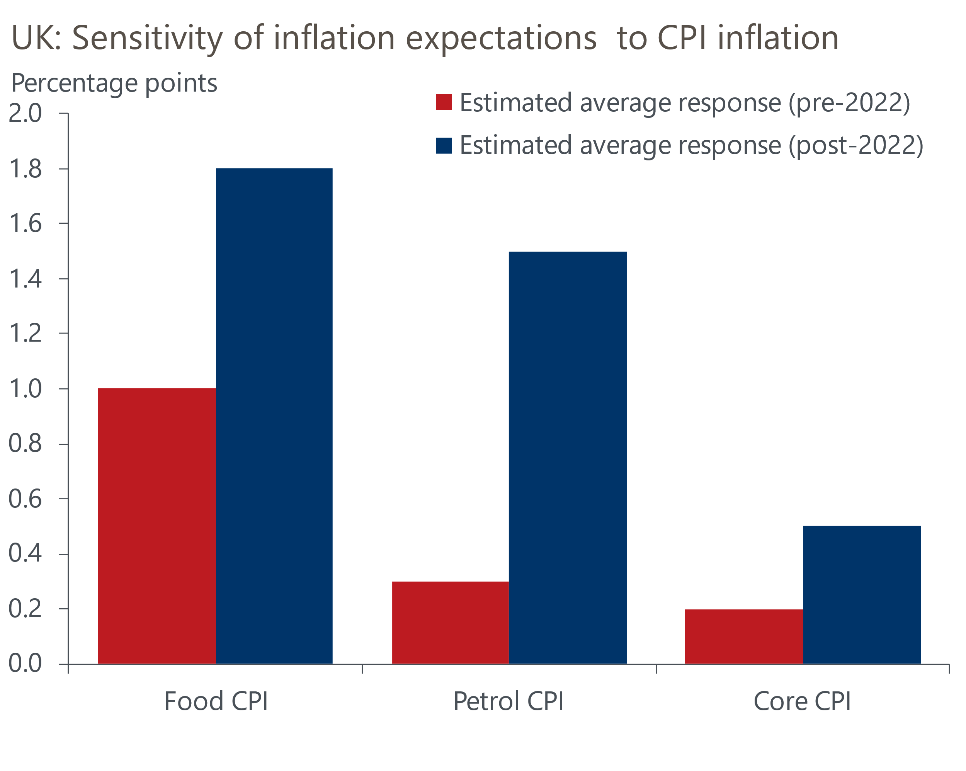
Source: Bank of England Monetary Policy Report

Though the week's inflation news does little to shift the outlook, it plays to some of the concerns expressed by several MPC members in August's minutes that recent higher inflation rates would raise inflation expectations among households and firms and contribute to greater inflation persistence.
Indeed, speaking at a Banco de México conference this week, external MPC member Catherine Mann put significant emphasis on recent analysis undertaken by BoE staff, which indicated that inflation expectations are particularly sensitive to developments in food and fuel price inflation, and that this sensitivity has risen in recent years (Chart 1). In her view, the temporary hump in inflation this year, together with elevated food prices and inflation expectations, increased the risk of generating second-round effects that could keep inflation above the BoE's 2% target for longer.
Against this backdrop, Mann argued that her hawkish dissent at the August meeting was consistent with her 'activist approach to monetary policy'. This reflects her view that keeping Bank Rate unchanged is currently appropriate to "maintain the tight monetary policy stance needed to lean against inflation persistence", but that she is also prepared to implement large cuts to Bank Rate should domestic demand weaken significantly. However, there is little suggestion that other committee members are adopting a similar approach to policymaking.
At the Federal Reserve's Jackson Hole gathering over the weekend, BoE Governor Andrew Bailey suggested that the weakness in GDP growth may not be enough to pull inflation back to target quickly. He argued that this partly reflected the drag on potential output growth – the rate at which the economy can grow without generating excess inflation – from poor workforce participation and productivity growth.
On balance, we don't think this week's comments from Bailey and Mann move the monetary policy debate in any meaningful way. The September MPC meeting in a few weeks' time will almost certainly see Bank Rate held at 4%. The focus of that meeting will be on the MPC's vote on the 2025-2026 quantitative tightening target. With the BoE having recently acknowledged that changes in gilt market conditions posed a risk that QT could have a greater impact on market functioning in the future, we expect the MPC will vote to lower next year's QT target to around £75bn-£80bn, from the current pace of £100bn per year. This is broadly in line with the consensus expectation expressed in the BoE's latest Market Participants Survey (Chart 2). We also think the BoE will focus active gilt sales on short- and medium-dated gilts rather than longs.
Chart 2: Market participants expect a sharp slowdown in the BoE's QT programme
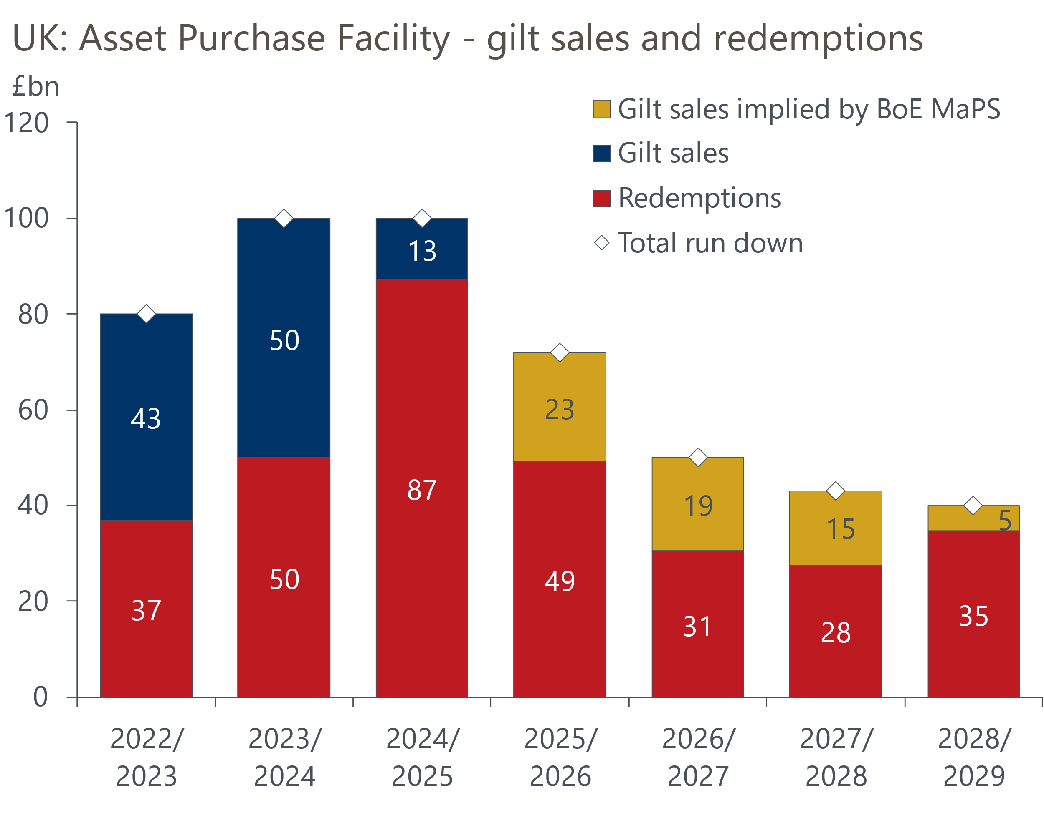
Source: Oxford Economics calculations using data from Haver Analytics & Bank of England
The real debate is around the November meeting. Following the MPC's hawkish pivot earlier this month, financial market pricing now suggests there's a relatively slim chance of a 25bps cut in November. We still think the probability of a cut is closer to a coin toss than market pricing implies, given the plethora of data due to be released between now and the November meeting. We suspect GDP growth in Q3 is likely to disappoint, but that Governor Bailey's reaction to upcoming economic releases will be key to the vote.

The week ahead
Next week should prove much busier, with several economic releases to look forward to. The first of those is the Bank of England's Money & Credit data for July. We expect to see a very modest improvement in mortgage activity during the month as the market continues to recover from the impact of the change in stamp duty thresholds at the end of March, while a decline in quoted mortgage rates in July is likely to have supported demand. Therefore, we have pencilled in a slight rise in mortgage approvals to 64,400, from 64,200 in June.
However, June's pickup in gross mortgage lending was unusually strong, so we think there's a good chance that this increase partially unwound in July. We anticipate that net mortgage lending slipped to £3.2bn in July, from £5.3bn a month earlier.
On the unsecured side, an unwinding of May's chunky rise in repayments and lower gross lending contributed to a pickup in net lending in June. We think repayments may have fallen slightly further in July. As a result, we estimate that net consumer credit was £1.6bn in July, up from £1.4bn in June.
August's flash S&P Global survey reported a pickup in private sector activity growth. This improvement was entirely driven by the services sector, while manufacturing output remained soft amid a lack of new orders and intense competitive pressures. We expect next week's final survey to reiterate this picture and show signs of a modest rebound in the construction PMI, after a very sharp fall in July.
Next week also sees the release of July's retail sales data, after the Office for National Statistics postponed its publication last week to "allow for further quality assurance". The retail sales data is always very volatile, but this year's swings have been particularly large. The level of sales in the non-food and non-store categories in June was much higher than in previous months, so we think there's scope for some payback in July's data. We forecast a 0.2% month-on-month fall in sales in July.
Table 1: Week ahead calendar
Date | Events | Period | Measure | Unit | Previous | Forecast
Sep 1 | Mortgage approvals | Jul | Level | 000s | 64.2 | 64.4
Sep 1 | Mortgage lending | Jul | Net lending | £bn | 5.3 | 3.2
Sep 1 | Consumer credit | Jul | Net lending | £bn | 1.4 | 1.6
Sep 1 | Nationwide house prices | Aug | m/m | % | 0.6 | 0.2
Sep 1 | Nationwide house prices | Aug | y/y | % | 2.4 | 2.8
Sep 1 | S&P Global manufacturing | Aug | PMI | % bal | 47.3 | 47.3
Sep 3 | S&P Global composite | Aug | PMI | % bal | 53.0 | 53.0
Sep 3 | S&P Global services | Aug | PMI | % bal | 53.6 | 53.6
Sep 4 | S&P Global construction | Aug | PMI | % bal | 44.3 | 46.2
Sep 5 | Retail sales inc fuel | Jul | m/m | % | 0.9 | -0.2
Sep 5 | Retail sales inc fuel | Jul | y/y | % | 1.7 | 0.6
Sep 5 | Halifax house prices | Aug | m/m | % | 0.4 | 0.3
Sep 5 | Halifax house prices | Aug | y/y | % | 2.4 | 2.3
Source: Oxford Economics

Key forecasts
Table 2: UK forecast overview
(Annual percentage changes unless specified)
 | 2023 | 2024 | 2025 | 2026 | 2027 | 2028
GDP | 0.4 | 1.1 | 1.3 | 0.9 | 1.3 | 1.7
Private consumption | 0.5 | 0.6 | 1.0 | 1.0 | 1.2 | 1.7
Fixed investment | 0.3 | 1.5 | 1.9 | 1.0 | 1.6 | 2.0
Government consumption | 1.6 | 3.0 | 1.8 | 1.8 | 1.6 | 1.7
Exports of goods and services | -0.4 | -1.2 | 2.2 | 0.2 | 1.2 | 1.4
Imports of goods and services | -1.2 | 2.7 | 3.9 | -0.9 | 1.1 | 1.4
Industrial Production | -0.8 | -1.2 | 0.3 | -0.4 | 0.8 | 1.2
Consumer prices | 7.3 | 2.5 | 3.4 | 2.7 | 2.4 | 2.1
Unemployment rate (%) | 4.1 | 4.3 | 4.7 | 4.9 | 4.8 | 4.4
Current a/c balance (% of GDP) | -3.5 | -2.7 | -3.3 | -3.1 | -2.9 | -2.8
Government balance (% of GDP) | 5.2 | 5.2 | 4.4 | 3.5 | 2.9 | 2.6
Central bank policy rate (%, EOP) | 5.25 | 4.75 | 3.75 | 3.00 | 2.50 | 2.50
10yr govt. bond yield (%, EOP) | 3.54 | 4.57 | 4.63 | 4.13 | 3.49 | 3.35
Exchange rate (US$ per £, EOP) | 1.27 | 1.25 | 1.33 | 1.34 | 1.34 | 1.34
Exchange rate (euro per £, EOP) | 1.15 | 1.21 | 1.15 | 1.15 | 1.15 | 1.15
Source: Oxford Economics
Table 3: Quarterly forecasts for the UK
 | 2025 |  |  |  | 2026
 | Q1 | Q2 | Q3 | Q4 | Q1 | Q2 | Q3 | Q4
GDP (% year) | 1.3 | 1.2 | 1.2 | 1.3 | 0.8 | 0.7 | 0.9 | 1.0
CPI inflation (% year) | 2.8 | 3.5 | 3.8 | 3.6 | 3.3 | 2.4 | 2.5 | 2.5
Bank Rate (%, EOP) | 4.50 | 4.25 | 4.00 | 3.75 | 3.50 | 3.25 | 3.25 | 3.00
10yr gilt yield (%, EOP) | 4.70 | 4.48 | 4.70 | 4.63 | 4.56 | 4.44 | 4.30 | 4.13
US$ per £ (EOP) | 1.29 | 1.37 | 1.33 | 1.33 | 1.33 | 1.33 | 1.34 | 1.34
Euro per £ (EOP) | 1.20 | 1.17 | 1.15 | 1.15 | 1.15 | 1.15 | 1.15 | 1.15
Source: Oxford Economics

Latest Country Economic Forecast:
August 20, 2025

Recent publications

Data Insights
PMI surprise does not necessarily mean a growth pickup
A tax rising Budget is on the cards
Higher inflation in July shouldn't exacerbate the MPC's worries
Strong June and April's upward revision rescue Q2 for GDP
Jobs market offers MPC little confidence on disinflation

Research Briefings
Tight BoE vote to cut casts doubt on the path for rates
MPC Preview - The case for faster cuts has faded for now
Why interest rate cuts remain a blunt tool
BoE likely to slow QT to avoid adding to gilt market strains
How the sectoral mix of jobs is changing and what it means

Contacts

Oxford Economics' UK team
- Andrew Goodwin - Chief UK Economist - agoodwin@oxfordeconomics.com
- Edward Allenby - UK Economist - eallenby@oxfordeconomics.com

